Terraform workspaces allow you to manage multiple instances of a single configuration, which is particularly useful for managing different environments such as development, staging, and production. Here's a step-by-step guide on how to create and use Terraform workspaces:

**Step 1: Initialize Your Terraform Configuration**

1. **Create or Navigate to Your Terraform Project**:
   * Navigate to your Terraform project directory in your terminal.
2. **Initialize Terraform**:
   * Run the following command to initialize your Terraform configuration:



**Step 2: Create and Manage Workspaces**

1. **Create a New Workspace**: To create a new workspace, use the following command



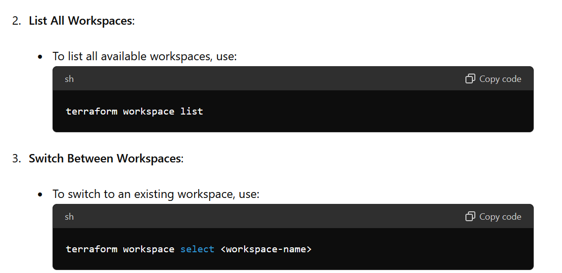

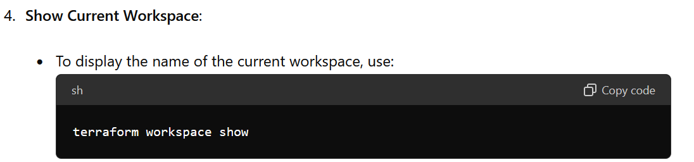

Exploring terraform workspace:

